- Create a lifeline of meaningful moments
Use a large sheet of paper. Write “Lifeline” at the top of the page.
Draw your lifeline, whether that is circular, straight, or some other shape.
Try to leave room for writing on both sides of the line.

You may want to use a spiral shape. The spiral is an ancient geometric shape used in many cultures throughout the world. Many plants and animals incorporate the spiral shape and it can be found in snails. Seashells as well as natural occurrences such as whirlpools. It can symbolize your ever-evolving transformation.

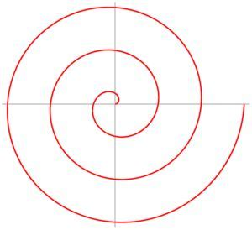

Draw short lines to mark each decade of your life, past, present, and future. Write “Now” in the place that represents your current age.

Start at the beginning of your life. Write in significant events, from the time of your birth to the present time. Focus on events where you experienced significant growth, a personal transformation, a major life event, went after or accomplished an important goal, and times when your life was profoundly altered in other ways.

What were some meaningful experiences? What were you doing? What did you learn?
Were these experiences to do with school or with your personal life?

Imagine your life continuing along this lifeline into the future. What significant milestones do you want to reach at various times in the future?

Write them in, along your lifeline, at the appropriate place.

You might find it helpful to frame your inquiries like this: “What would I most like to accomplish between the years of X and Y?” “What would I want to have done?” “Who would I like to be by then?” “What would I like to have by then?”

Don’t let yourself be bound by overly reasonable, practical thinking. This inquiry is about what you would really like to have. At this point, it is not about definite commitments.

2. Take one accomplishment or transformative experience and write about it. What strength did you use? What did you learn? How did it feel? What made it meaningful?

--

