DOUG LANTRY
"Stay Sweet As You Are": An Analysis of Change
and Continuity in Advertising Aimed at Women
Doug Lantry wrote this analysis of three print ads for a first-year writing course at the University of Akron.
Magazine advertisements aimed at American women have a long history of pushing things like makeup, mouthwash, soap, and other products that reinforce men's roles in women's lives. The concept of personal hygiene has been used to convey the message that "catching" a man or becoming a wife is a woman's ultimate goal, and in advertisements from the 1920s, 1930s, and 1950s this theme can be traced through verbal and visual content.
For example, a 1922 ad for Resinol soap urges women to "make that dream come true" by using Resinol (see Fig. 1). The dream is marriage. The premise is that a bad complexion will prevent marriage even if a woman has attributes like wit and grace, which the ad identifies as positive. Blotchy skin, the ad says, will undermine all that. The word repellent is used for emphasis and appears in the same sentence as the words neglected and humiliated, equating the look of the skin with the state of the person within. Of course, Resinol can remedy the condition, and a paragraph of redemption follows the paragraph about being repellent. A treatment program is suggested, and the look and feel of "velvety" skin are only "the first happy effects," with eventual marriage (fulfillment) implied as the ultimate result of using Resinol soap.
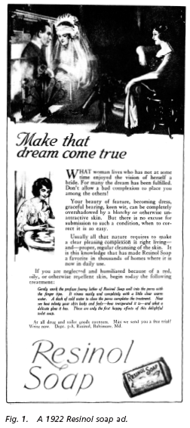
Visual content supports the mostly verbal ad. In a darkened room, a lone woman peers dreamily into a fireplace, where she sees an apparition of herself as a bride in a white veil, being fulfilled as a person by marriage to a handsome man. She lounges in a soft chair, where the glow of the image in the fireplace lights her up and warms her as much as the comforting fire itself. A smaller image shows the woman washing with Resinol, contentedly working her way toward clear skin and marriage over a water-filled basin suggestive of a vessel of holy water. This image is reinforced by her closed eyes and serene look and by the ad's suggestion that "right living" is a source of a good complexion.
A somewhat less innocent ad appeared more than a decade later, in 1934 (see Fig. 2). That ad, for Lux soap, like the one for Resinol, prescribes a daily hygiene regimen, but it differs significantly from the Resinol message in that it never mentions marriage and uses a clearskinned movie star as proof of Lux's effectiveness. Instead of touting marriage, Lux teaches that "a girl who wants to break hearts simply must have a tea-rose complexion." Romance, not marriage, is the woman's goal, and competition among women is emphasized because "girls who want to make new conquests . . . [are] sure to win out!" by using Lux. Lux's pitch is more sophisticated than Resinol's, appealing to a more emancipated woman than that of the early 1920s and offering a kind of evidence based on science and statistics. The text cites "9 out of 10 glamorous Hollywood stars" and scientists who explain that Lux slows aging, but it declines to cite names, except that of Irene Dunne, the ad's star. The unnamed stars and scientists give the ad an air of untruthfulness, and this sense is deepened by the paradox of the ad's title: "Girls who know this secret always win out." If Lux is a secret, why does it appear in a mass-media publication?
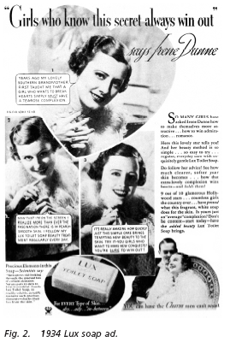
Like Resinol, Lux urges women to seek love and fulfillment by enhancing their outward beauty and suggests that clear skin means having "the charm men can't resist."
The Lux ad's visual content, like Resinol's, supports its verbal message. Several demure views of Irene Dunne emphasize her "pearlysmooth skin," the top one framed by a large heart shape. In all the photos, Dunne wears a feathery, feminine collar, giving her a birdlike appearance: she is a bird of paradise or an ornament. At the bottom of the ad, we see a happy Dunne being cuddled and admired by a man.
The visual and verbal message is that women should strive, through steps actually numbered in the ad, to attain soft, clear skin and hence charm and hence romance. Not surprisingly, the ad uses the language of battle to describe the effects of clear skin: girls who use Lux will "make new conquests!" and "win out!" Similar themes are developed for a younger audience in a 1954 ad for Listerine mouthwash (see Fig. 3). This time the target is no longer grown women but teenage girls: "If you want to win the boys . . . Stay Sweet As You Are!" Because attracting men would be inappropriate for teenagers, boys are the catch of the day in the Listerine ad. The idea of staying sweet means on the surface that girls should have nice breath, but the youthful context of the ad means that for women to be attractive they must stay young and "stay adorable," preferably with the girlish innocence of a teenager. The consequences of not staying sweet are clear: if you don't use Listerine every morning, every night, and before every date, "you're headed for boredom and loneliness." If you do use Listerine, there are "good times, good friends, and gaiety ahead."
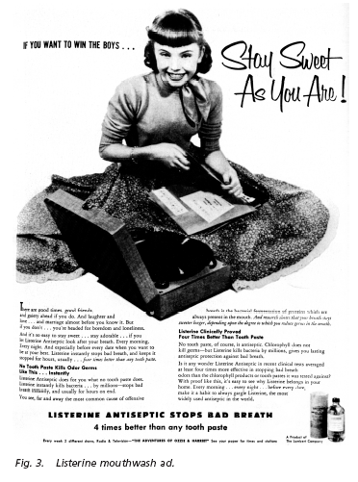
Like Lux, Listerine relies on science as well as sex. With talk of "the bacterial fermentation of proteins," research, and clinical tests, the mouthwash props up its romantic and sexual claims by proclaiming scientific facts. Listerine is "4 times better than any tooth paste," the ad proclaims "With proof like this, it's easy to see why Listerine belongs in your home."
Visuals contribute to the message, as in the other ads. The central image is a photo of a perky, seemingly innocent teenage girl playing records on a portable phonograph. A vision of midcentury American femininity, she wears a fitted sweater, a scarf tied at the neck (like a wrapped present?), and a full, long skirt. She sits on the floor, her legs hidden by the skirt; she could be a cake decoration. Leaning forward slightly, she looks toward the reader, suggesting by her broad smile and submissive posture that perhaps kissing will follow when she wins the boys with her sweet breath. The record player affirms the ad's teenage target.
The intended consumers in the Resinol, Lux, and Listerine ads are women, and the message of all three ads is that the product will lead to—and is required for—romantic or matrimonial success. Each ad implies that physical traits are paramount in achieving this success, and the ads' appearance in widely circulated magazines suggests that catching a man (whether or not she marries him) is the ultimate goal of every American woman. While there is a kind of progress over time, the ads' underlying assumptions remain constant. There is evidence of women's increasing sophistication, illustrated in the later ads' use of science and "objective" proof of the products' effectiveness. Women's development as individuals can also be seen in that marriage is not presupposed in the later ads, and in the case of Lux a single woman has a successful career and apparently has her pick of many partners.
Still, one theme remains constant and may be seen as a continuing debilitating factor in women's struggle for true equality in the world of sex roles: pleasing men is the prerequisite for happiness. Despite apparent advances on other levels, that assumption runs through all three ads and is the main selling point. The consumer of Resinol, Lux, and Listerine is encouraged to objectify herself, to become more physically attractive not for her own sake but for someone else's. The women in all three ads are beautifying themselves because they assume they must "make new conquests," "win the boys," and "make that dream come true."
Lantry summarizes each ad clearly and focuses his analysis on a theme running through all three ads: the concept that to find happiness, a woman must be physically attractive to men. He describes patterns of images and language in all three ads as evidence.

