What’s a Rhetorical efinition With Examples
A rhetorical situation is anything that has rhetoric in it. This Penlighten post will help you understand rhetorical situation with its definition and examples.
Home / Uncategorized / What’s a Rhetorical Situation? Here’s the Definition With Examples
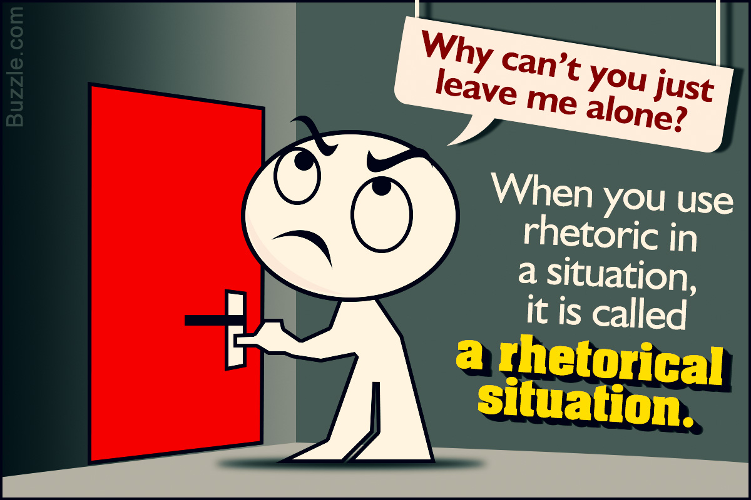
A rhetorical situation is anything that has rhetoric in it. This Penlighten post will help you understand rhetorical situation with its definition and examples.
Rhetoric is the art of ruling the minds of men.
― Plato
Aristotle defined rhetoric as “an ability, in each particular case, to see the available means of persuasion” (Aristotle Rhetoric I.1.2, Kennedy 37).

over the last century or so, the academic definition and use of “rhetoric” has evolved to include any situation in which people consciously communicate with each other. In brief, individual people tend to perceive and understand just about everything differently from one another (this difference varies to a lesser or greater degree depending on the situation, of course). This expanded perception has led a number of more contemporary rhetorical philosophers to suggest that rhetoric deals with more than just persuasion. Instead of just persuasion, rhetoric is the set of methods people use to identify with each other—to encourage each other to understand things from one another’s perspectives (see Burke 25). From interpersonal relationships to international peace treaties, the capacity to understand or modify another’s perspective is one of the most vital abilities that humans have. Hence, understanding rhetoric in terms of “identification” helps us better communicate and evaluate all such situations.

*Other rhetorical terms:
exigence. noun. 1. The condition of being in need of immediate assistance: distress, exigency, hot water, trouble. 2. A condition in which something necessary or desirable is required or wanted: exigency, necessity, need. 3.

Ethos, Pathos, Logos

To understand a rhetorical situation, you must first know what rhetoric means. Any sentence said or written that is more of a statement, which does not need any reply or feedback, and is meant to modify the perspective of the listener or reader, is a rhetoric.
A rhetorical statement makes use of devices and methods that make it more persuasive. These devices might include metaphors (comparing one thing to another)
- I was lost in a sea of nameless faces.
- Her eyes were fireflies.

Difference Between Simile and Metaphor
March 26, 2019 By Surbhi S Leave a Comment
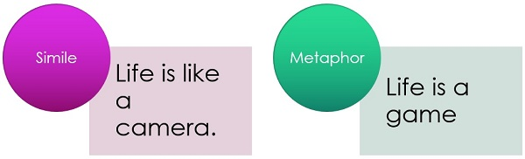

allegory (using an idea to represent another) that give the statement a strong meaning,
An allegory is the rhetorical strategy of extending a metaphor through an entire narrative.
For example, the story of The Tortoise and the Hare
and change the perspective of people listening to or reading it.

Example: Keep that away from me, will you?
This statement does not need an answer. It is an implied question that wants something to be done right away. So, this is a rhetoric question.
*There exist three views on a rhetorical situation:
- A situation is what gives rise to rhetoric.
- Rhetoric gives rise to situations, by making issues salient (more noticeable).
- A rhetor is a rhetoric artist, who creates salience through his knowledge.

Constituents of a Rhetorical Situation
A rhetorical situation is a rhetorical event consisting of an exigence (issue), an audience, and a set of constraints, which can be represented graphically by the rhetorical situation triangle. Lloyd Bitzer who wrote an influential piece in the field of rhetoric titled ‘The Rhetorical Situation’, in 1968, identified these three key components that define a rhetorical situation.
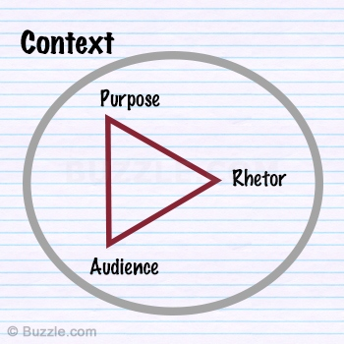
Rhetorical Situation

Exigence:
Bitzer says “Any exigence is an imperfection marked by urgency; it is a defect, an obstacle, something waiting to be done, a thing which is other than it should be,” and “rhetoric comes into existence as a response to situation [exigence], in the same sense that an answer comes into existence in response to a question’.
- An exigence is rhetoric when a speaker has to intervene to make an influential and persuasive speech to the audience.
- An exigence is rhetoric when it demands a positive change.

Audience:
Bitzer says, “A rhetorical audience consists only of those persons who are capable of being influenced by discourse and of being mediators of change.”
- To bring about a positive change, the rhetor should be able to make an impressive and influential speech for an audience that would respond to him in a willingness to bring a change.
- The audience needs to be such that they be interested in what the rhetor has to say.

Constraints:
“Every rhetorical situation contains a set of constraints made up of persons, events, objects, and relations, which are part of situation because they have the power to constrain decision and action needed to modify the exigence.”
● Constraints constitute that part of a rhetorical situation that influence the audience. The rhetor, the cause that makes the rhetor speak, everything involved in the situation, and the audience that will make the change possible, are all constraints.

Elements of Rhetorical Situation
▶ A text (a piece of communication)
▶ An author (someone who uses this communication)
▶ An audience (recipient of the communication)
▶ Purposes (the varied reasons that both authors and audiences communicate)
▶ A setting (the time, place, and environment surrounding a moment of communication)
“Ask not what your country can do for you – ask what you can do for your country.” ― J. F. Kennedy
▶ Text: Ask not what your country can do for you – ask what you can do for your country.
▶ Author: J. F. Kennedy
▶ Audience: The people of his country.
▶ Purpose: Motivating the people to do something positive for their country.
▶ Setting: The time, place and environment must surely be of great importance for such a statement to be made.
J. F. Kennedy repeats the words in the same sentence in a reverse order. Just this rhetoric grabs more than half the attention, the rest definitely is contained in the meaning of it.
A rhetorical situation arises from the need of time, of persuasion and emphasis, a need for change, a striking and thought-provoking idea that would motivate or inspire, or at least give the people a chance to contemplate the situation being discussed. Rhetorical situations are made from these intentions solely. They are hardly meant to be funny, and when they are, they are mostly counted as sarcasms.

X

